Department of Computer Engineering
Program name :- Computer Engineering Class: S.Y. B. Tech Div:- C
Name of Student: Ganesh Solanke Batch:- __C -2____ Course Name:- Personal Finance Advisor Bot
PRN No :- 251110155 Roll No:- 12326 Sem :- III______ Course :- BSFI (Online)


SMARTBRIDGE | SKILLWALLET

Personal Finance Advisor Bot: AI-Powered Finance Management
Project Description :-
Personal Finance Advisor Bot is a web-based finance management application designed to help users record income and expenses, monitor monthly savings, and understand their spending habits through a simple and interactive interface. It is intended to make basic personal budgeting easier for students, beginners, and everyday users.
The application dashboard presents monthly income, total expenses, net savings, and budget status. Users can navigate to Income, Expenses, Budget, AI Advisor, Report, and Goals sections. The expense form supports a description, amount, category, date, and optional notes. AI-assisted guidance depends on the application’s configured AI service and available credentials.
The application is deployed on Render and uses a Flask-based backend with database support. The interface is designed to make common finance tasks accessible from a web browser. Screenshots included in this report document the landing page, dashboard, and Add Expense form as shown in the supplied project images.

Technology & AI :-
Frontend: HTML / CSS / JavaScript
Backend: Python / Flask
Database: SQLite with Flask-SQLAlchemy

AI Advisor: Gemini API (when configured)
Deployment: Render
Application server: Gunicorn
Configuration: Environment variables and .env.example
Repository: GitHub

Key Features :-
• User registration and sign-in interface
• Monthly dashboard for income, expenses, net savings, and budget status
• Add and manage income records
• Add expenses with description, amount, category, date, and optional notes
• Budget management and spending overview
• AI Advisor section for financial guidance when configured
• Report and Goals sections in the application navigation
• Web-based interface accessible through a browser
• Live deployment hosted on Render

Scenarios :-
Scenario 1: A user signs in and opens the dashboard to review the selected month’s income, expenses, savings, and budget status. The dashboard shows summary values based on the records entered for that month.
Scenario 2: A user records a new expense by entering its description, amount, category, date, and optional notes, then saves the form. The expense can then be used in the application’s spending summary if the save operation succeeds.
Scenario 3: A user records income and expenses to compare money received with money spent and review the resulting net savings. The displayed values depend on the records and month selected.
Scenario 4: A user opens the AI Advisor, Report, or Goals section to explore additional finance tools. Availability and results should be verified in the deployed application before the project is demonstrated or submitted.

Milestones :-
Milestone 1 – Planning & Requirement Analysis
Identify the main needs of a personal finance application and plan the dashboard, income, expenses, budget, AI Advisor, report, and goals sections.
Milestone 2 – Backend & Database Setup
Build the Flask application structure and configure database support using Flask-SQLAlchemy and SQLite.
Milestone 3 – User Interface & Finance Features
Develop the landing page, dashboard, and forms for recording income and expenses, including monthly financial summaries.
Milestone 4 – AI Support & Additional Sections
Provide an AI Advisor section where supported by the configured AI service, alongside the Budget, Report, and Goals sections.
Milestone 5 – Testing & Deployment
Test the main user flows, check the deployed website, confirm that no secrets are committed to GitHub, and deploy the application using Render.

Conclusion :-
Personal Finance Advisor Bot brings common personal finance tasks together in one web application. Its dashboard and entry forms provide a straightforward way to record income and expenses and review monthly savings and budget status. The project demonstrates the use of Flask, a database, a browser-based interface, and deployment on Render. Each feature should be tested in the live application before being described as fully operational.

Expected Outcome :-
The expected outcome is a user-friendly web application that helps users organize income and expenses, view monthly financial summaries, and explore budgeting and AI-assisted guidance features. The project also provides a deployed website and a public source-code repository for demonstration and academic evaluation.

Website Screenshots
The following screenshots were supplied for this project and illustrate the visible interface. They are documentation evidence; test each feature in the deployed website to confirm current behavior.

Figure 1: FinanceBot landing page
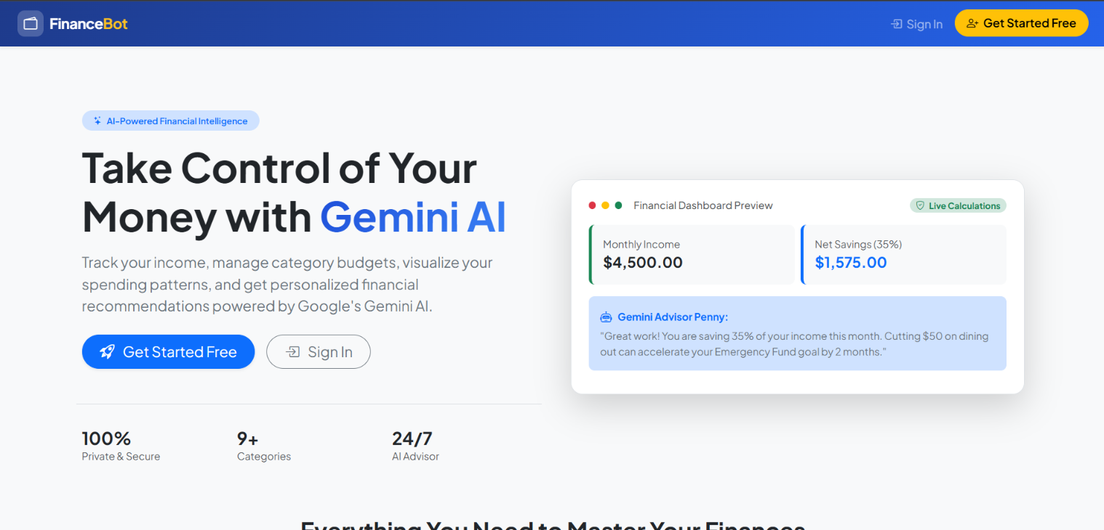
Figure 1: FinanceBot landing page

Figure 2: Monthly finance dashboard
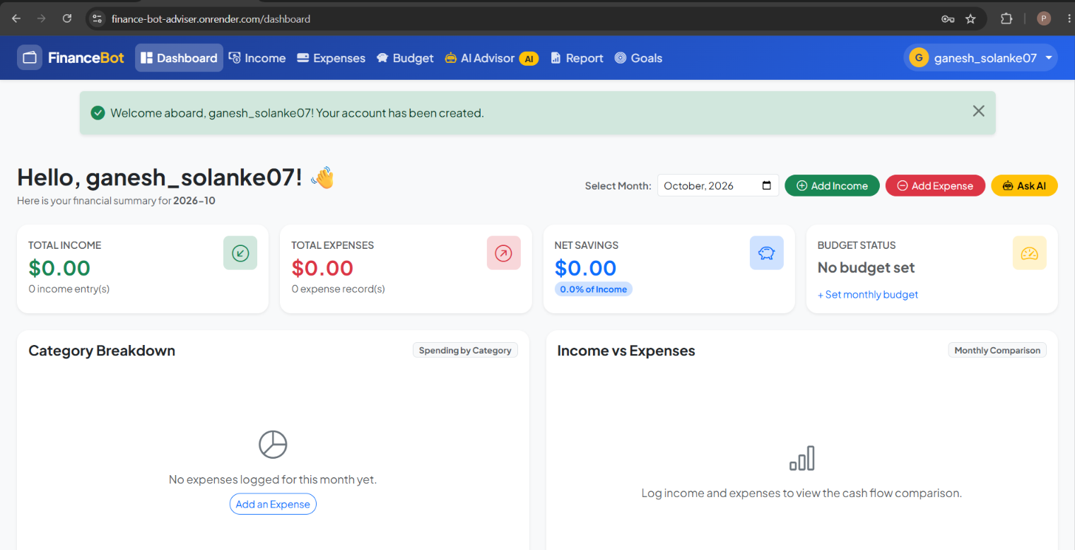
Figure 2: Monthly finance dashboard

Figure 3: Add Expense form
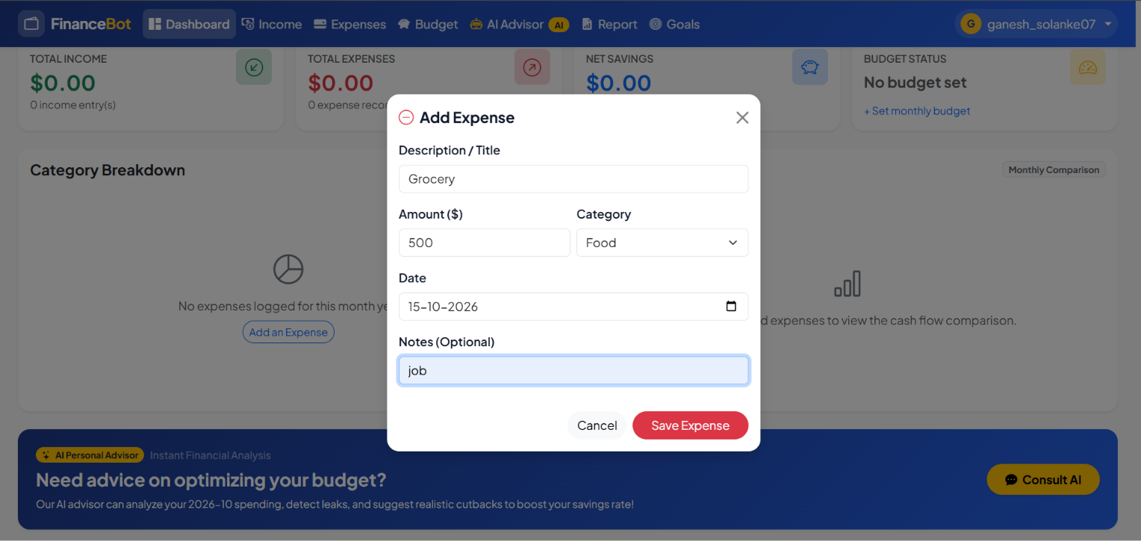
Figure 3: Add Expense form

